**Short FRQ Practice:** Cell Communication

*AP Biology*

Write your response in the space provided following each question. Only material written in the space provided will be scored. Answers must be written out in paragraph form. Outline form is not acceptable. Labeled diagrams may be used to supplement discussion, but unless specifically called for by the question, a diagram alone will not receive credit.

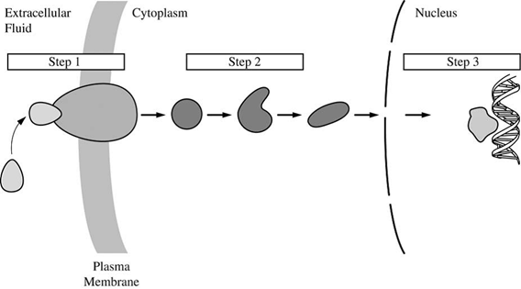

**The figure above represents a generalized hormone-signaling pathway. Briefly explain the role of each numbered step in regulating target gene expression.**

**Short FRQ Practice:** Cell Communication

*AP Biology*

Write your response in the space provided following each question. Only material written in the space provided will be scored. Answers must be written out in paragraph form. Outline form is not acceptable. Labeled diagrams may be used to supplement discussion, but unless specifically called for by the question, a diagram alone will not receive credit.



**The figure above represents a generalized hormone-signaling pathway. Briefly explain the role of each numbered step in regulating target gene expression.**